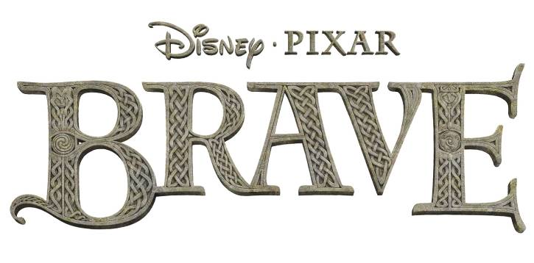

**GLOSSARY**

*A story set in Scotland would be jiggery pokery without its share of Scottish words and phrases. And crivens, “Brave” has plenty! But it would all be for naught unless accompanied by a proper glossary, so here goes…*

AUTOCHTHONOUS

Indigenous, native

* Taught to filmmakers by Emma Thompson (voice of Queen Elinor), who used it to describe “Brave’s” Castle Dunbroch because it appears to have grown right out of the earth.

BLUE WODE

A blue dye extracted from a cabbage-type plant used by inhabitants of ancient Scotland to paint their bodies

* Lord MacGuffin and Young MacGuffin paint their bodies in blue wode to proclaim that they are ready for battle at any moment.

BRAE

Hill

BUNCH OF GALOOTS

Many fools

* galoot = clumsy, oafish person

CARNYX

A Celtic trumpet with a bell shaped like a boar’s head. Held vertically so it can be heard in large crowds, a carnyx was used during wartime to send troops into battle.

* In “Brave,” it signals the start of the Highland Games.

CRIVENS, YOU’RE FIERCE

Wow! You’re cool or ferocious or tough!

* crivens = expression of surprise or shock

DANCING TATTY BOGLE

An expression that describes something outlandish or imaginary

* tatty = shabby, cheap
* bogle, boggle or bogill = ghost or folkloric being

DORIC

A dialect from the Aberdeenshire region in Scotland

* Elgin native Kevin McKidd (voice of MacGuffin and Young MacGuffin), who learned Doric from his grandfather, proposed to filmmakers for Young MacGuffin to speak the incomprehensible dialect in “Brave.”

DREADFUL COLLYWOBBLES

Unwanted stomachache or a bad case of the nerves

* collywobbles = upset stomach; intestinal disturbances or a feeling of apprehension

FOR NAUGHT

For no reason

FINISH WHAT HE GUDDLED IN THE FIRST PLACE

Fix, clean up or otherwise remedy something that’s been horribly mishandled.

* guddle = make a mess of it

GAMY SPELL

An unfortunate bit of magic

* gamy = bad

GLEN

Small, narrow, secluded valley

GOOGLY OLD HAG

Outlandish, unattractive senior

* googly = strange, odd

GIANT HAVING A JIGGER IN THE BLUEBELLS

Similar to Dancing Tatty Bogle, something that’s absurd or fantastical

HAGGIS

Though some will joke that a haggis is a small animal native to Scotland, it is actually a traditional Scottish pudding made with sheep’s heart, liver and lungs, encased in a sheep’s stomach and cooked for several hours. Often served with “neeps and tatties" (turnips and potatoes).

HIGHLAND GAMES

Festivals that celebrate Scottish and Celtic culture and heritage, especially that of the Scottish Highlands. Includes competitions in piping and drumming, dancing, archery, caber tossing, stone put and other Scottish athletics, plus entertainment and exhibits.

JIGGERY POKERY

Nonsense

JINGS CRIVENS HELP MA BOAB

Oh my!

Exclamation of bewilderment or exasperation

KILT

A pleated and draped tartan fabric garment worn by Scottish men

* During the production of “Brave” director Mark Andrews and several animators wore kilts to work on Fridays—dubbed Kilt Fridays—to get in the spirit of Scotland and the film’s characters.

LASS

Girl

LAD

Boy

LOCH

Lake

MANKY DOGS

Unsavory person or being

* manky = dirty, worthless or in bad taste

MICHTY ME

Wow! Holy cow!

An exclamation of surprise, shock or being overwhelmed

NUMPTY

Useless individual

NUT ‘EM

Head-butt ‘em

SCAFFY WITCH

A tricky or slick being with magical powers

* scaffy = trickster

SCARED SIMPERIN’ JACKANAPES

Belittling description of a goofy and unworthy opponent

* simpering = silly smile
* jackanape = an insulting reference to a monkey or ape; a braggart; a mischievous child

SCUTTLE THE VIKING LONGSHIPS

Sink Viking ships by making holes in the bottom

STUFF HER GOB

Eat with abandon

* gob = mouth

TARTAN

A specially designed woven fabric that identifies a clan. April 6th is National Tartan Day in the United States.

TOSSING CABERS

A test of strength and skill seen in Highland Games in which the competitor raises a pole vertically with the small end down, and then throws it

* Caber = a long, tapered section of a tree trunk

TUMSHIE

Turnip… or foolish person. Or both.

WEE

Small

WE’LL BILE YUR HEED WAE DUMPLIN’ BREED; TAE MAKE AN URSINE STEW

* bile yer heed (boil your head) = don’t be ridiculous. Also used as an exclamation if someone is doing something stupid and it's annoying
* In “Brave” King Fergus sings what he’ll do to the demon bear Mor’du when he catches him to avenge his lost leg. Not only will he boil his head, but he’ll add dumplings to make a bear stew.

WILL O’ THE WISPS

Ghostly lights or small blue spirits that lead the way to treasure or doom.

* In “Brave,” the will o’ the wisps lead Merida to change her fate.

**ABOUT THE MOVIE:**

Set in the rugged and mysterious Highlands of Scotland, Disney•Pixar’s “Brave” follows the heroic journey of Merida (voice of Kelly Macdonald), a skilled archer and headstrong daughter of King Fergus (voice of Billy Connolly) and Queen Elinor (voice of Emma Thompson). Determined to change her fate, Merida defies an age-old custom sacred to the unruly and uproarious lords of the land: massive Lord MacGuffin (voice of Kevin McKidd), surly Lord Macintosh (voice of Craig Ferguson) and cantankerous Lord Dingwall (voice of Robbie Coltrane), unleashing chaos in the kingdom. When she turns to an eccentric Witch (voice of Julie Walters), she is granted an ill-fated wish and the ensuing peril forces Merida to harness all of her resources—including her mischievous triplet brothers—to undo a beastly curse and discover the meaning of true bravery. Directed by Mark Andrews and Brenda Chapman, and produced by Katherine Sarafian, “Brave” is a grand adventure full of heart, memorable characters and signature Pixar h or. Opens on June 22, 2012, in Disney Digital 3D™ in select theaters.